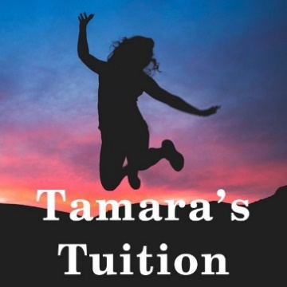
Themes and Ideas
List the ideas and themes mentioned in the novel.
To find the themes, ask ‘What do you think the author wants you to think? Why?’
Increase Your Word Power
List the unfamiliar words and the page number they appeared on. Look up their definitions and write them down. Go back and re-read the section now you know what that word means.

Active Reading
Bookmark

- Helps you retain the meaning.
- Makes it clear to you where you may be getting lost.
- Makes it easier to revise later.
Use these symbols
- on a post-it note. Allocate a different colour to each character or theme. NB you will need to erase all writing before using the novel in an exam.
! An important point
!! Very Important point
I agree
I disagree
? Puzzling – not sure I know what this means
?? Very puzzling – does not make sense to me
XQ marks a quote of a selected character e.g. DQ= Duncan’s Quote
XA marks an action of a selected character e.g. DA= Duncan’s Action
My Impression at the Beginning

Novel is set (when):

Novel is set (where):

Important Features of this time and place:
(you may need to research this)
Main Character #1
At the beginning what I know about ________________ is:

List evidence.
What does a character SAY?
THINK?
DO?
What do other characters say about them?
How do they act towards them?

In the middle:

By the end:
Main Character #2
At the beginning what I know about ________________ is:

In the middle:

By the end:

